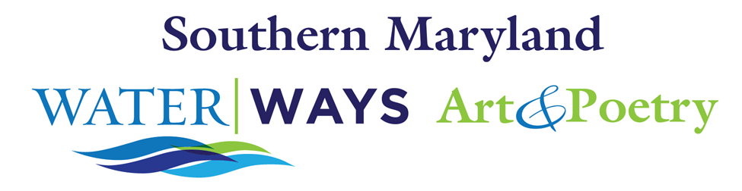

Email these 2 completed pages to WaterWaysArtAndPoetry@gmail.com. Your submission confirms that you are submitting previously unpublished work and that you give permission for Calvert Library and/or Calvert Library’s partners to publish your work on Calvert Library’s or partners’ websites, social media or in print form, without the expectation of remuneration. Calvert Library retains the right to first publishing until July 1, 2020. The author retains all copyrights to the submitted poem.
Title of the Art Piece that inspired your poetry:
Title of your poem:
Your poem (no more than 20 lines)

Your name:
Your address:
Your phone number:
Your email address:
Brief biography:

